The Grocery Galaxy: Mapping Insights
From BlinkIT
A data-driven voyage through shelves, sales, and smart decisions.

What is BlinkIT?
Just as The Flash transforms time in the comic universe Blinkit zips grocery supplies to customers' homes within 10-minute windows. The service known as Grofers originated in 2013 but underwent a brand transformation to Blinkit in 2021 to show dedication toward "in the blink of an eye" order delivery. Speed functions as Blinkit's source for transforming modern retail delivery systems with instant service capabilities. Zomato supports Blinkit which merges technological solutions and neighborhood stock management with smart dark store distribution to bring you milk and lotions before your hot beverage is ready. Instant grocery delivery through Blinkit represents more than retail because it presents "instant commerce indistinguishable from magic." The urban centers of India host Blinkit as an application that brings citizens an advanced lifestyle experience.
Presented by: PUNITH KUMAR VADDEPALLY – (Z23809942), NIKHITHA POTTIGARI – (Z23811316), SUSHANK YAMZALA – (Z23807461)
Course: ISM 6404 – Intro to Business Analytics and Big Data
Instructor: Dr. Ernesto Lee
Date: 04/24/2025
Tool: Power BI
🎯 Mission: Decode consumer patterns, outlet performance, and item trends using smart dashboards.

Introduction – Welcome to the Aisle of Data
When you enter a BlinkIT outlet you will find all product shelves are maximally filled and shopping carts are constantly rolling as customer data stories unfold through every barcode scan. The project focuses on revealing the collected stories.
Purpose of This Study
Our goal involved taking BlinkIT grocery sales data through a visualization process to obtain insightful condensed information. With Power BI we study the sales patterns including areas of maximum success together with their underlying reasons.
About the Dataset
The data collection consists of more than 8500 operational records which present information about various product types, outlet ratings and financial metrics along with fat content specific tags.
- 📁 Source: https://drive.google.com/drive/folders/1mKh61zKVBnPJN0A5lc77osGNkmNa-loI
- 📊 Columns:
  - Product Info: Item Identifier, Item Type, Fat Content, Weight, Visibility
  - Store Data: Outlet Size, Location Type, Establishment YearS
  - Performance Metrics: Sales, Rating
- 🔢 Rows: 8,523 stories waiting to be visualized.

Methodology – Navigating the Data Galaxy with Power BI 🚀
🛠️ Tool of Choice: Power BI
Power BI served as our spaceflight into data exploration since it offered all necessary tools for navigating data smoothly while being agile and intelligent. The combination of interface design with drag-and-drop function and DAX engine highlighted a perfect solution for transforming raw data into dynamic insights.
Why Power BI?
Power BI gives users the possibility to navigate dashboards by applying filters while viewing KPIs and enabling interactive visual storytelling just like a superhero cape for Excel. The platform delivers exceptional functionality to convert normal grocery records into strategic business reports. The system links directly to Excel with no need to invest additional preparation time on data. Users can benefit from rapid slicing capabilities and drilling operations through the system that directs navigation from broad business-wide patterns to individual product measurement points. Users can produce meaningful visualizations using the system features that incorporate KPI cards and dynamic filters together with theme customization options for business narrative purposes. Dashboards can be shared and explored interactively, making them not just reports, but data experiences.
🛠️ Top Features Used:
- Slicers (interactive filters)
- KPIs (Key Performance Indicators for instant metrics)
- Bar, line, and pie charts
- Tooltips & drill-downs (so users can explore more with less clutter)
🎨 Visualization Creation Process
The following format described the mission control checklist:
- Data Prep & Cleaning: The initial dashboard construction required the dataset to undergo cleaning procedures within Power BI’s Power Query Editor. We handled the missing values in important columns consisting of Item Weight through logical default replacements to protect data integrity. Standardization made all occurrences of "Low Fat" consistent for better clarity. Visual chart distortions were prevented through analysis and adjustment of outliers within Item Visibility measurement data. The data fields received a transformation that made the analysis easier to understand and read. The analysis received distinct contribution from every transaction by removing all duplicate rows. The entire dataset received data type adjustments to enable proper calculations together with filtering operations. All data preparation activities were documented in Applied Steps to create a transparent approach for repeating the workflow.
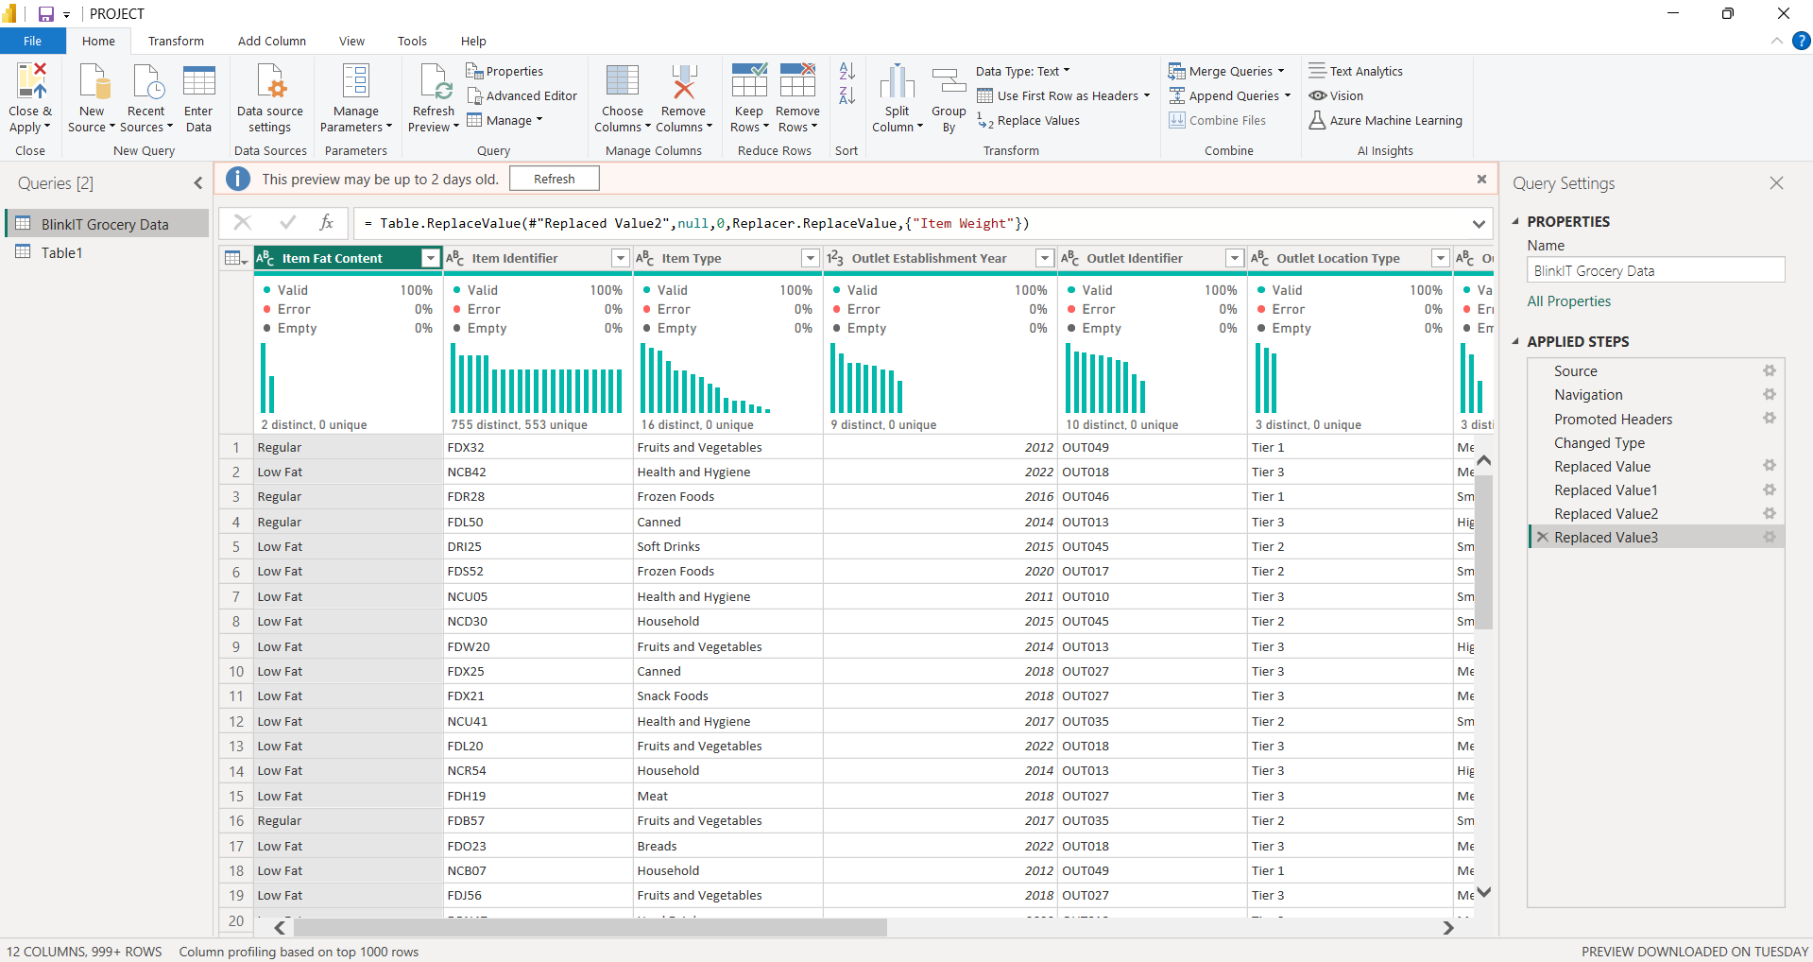
FIGURE 1: Data Transformation Workflow: Cleaning & Structuring BlinkIT Insights in Power Query
- Data Modeling: The Model View in Power BI allowed us to create a single data model through table interconnection structures. The BlinkIT Grocery Data main table connected through common Item Identifier and Outlet Identifier keys to Tables 1 and METRIX. The one-to-many relationship structure allowed dashboard users to accurately group and filter data throughout the platform. A check for duplicate entries and referential integrity enforcement-maintained relationship integrity in the system. The outlet establishment year field received hierarchical organization to allow analysts to view additional levels of detail within dashboards. The application reduced its usage of lookup tables in order to maintain system performance and prevent visual clutter. The review process checked how all relationship fields maintained consistent formatting and data types. The model provided an analytical backbone for the report which enabled smooth data filtering operations together with dependable KPI calculations and stable analytical foundations.
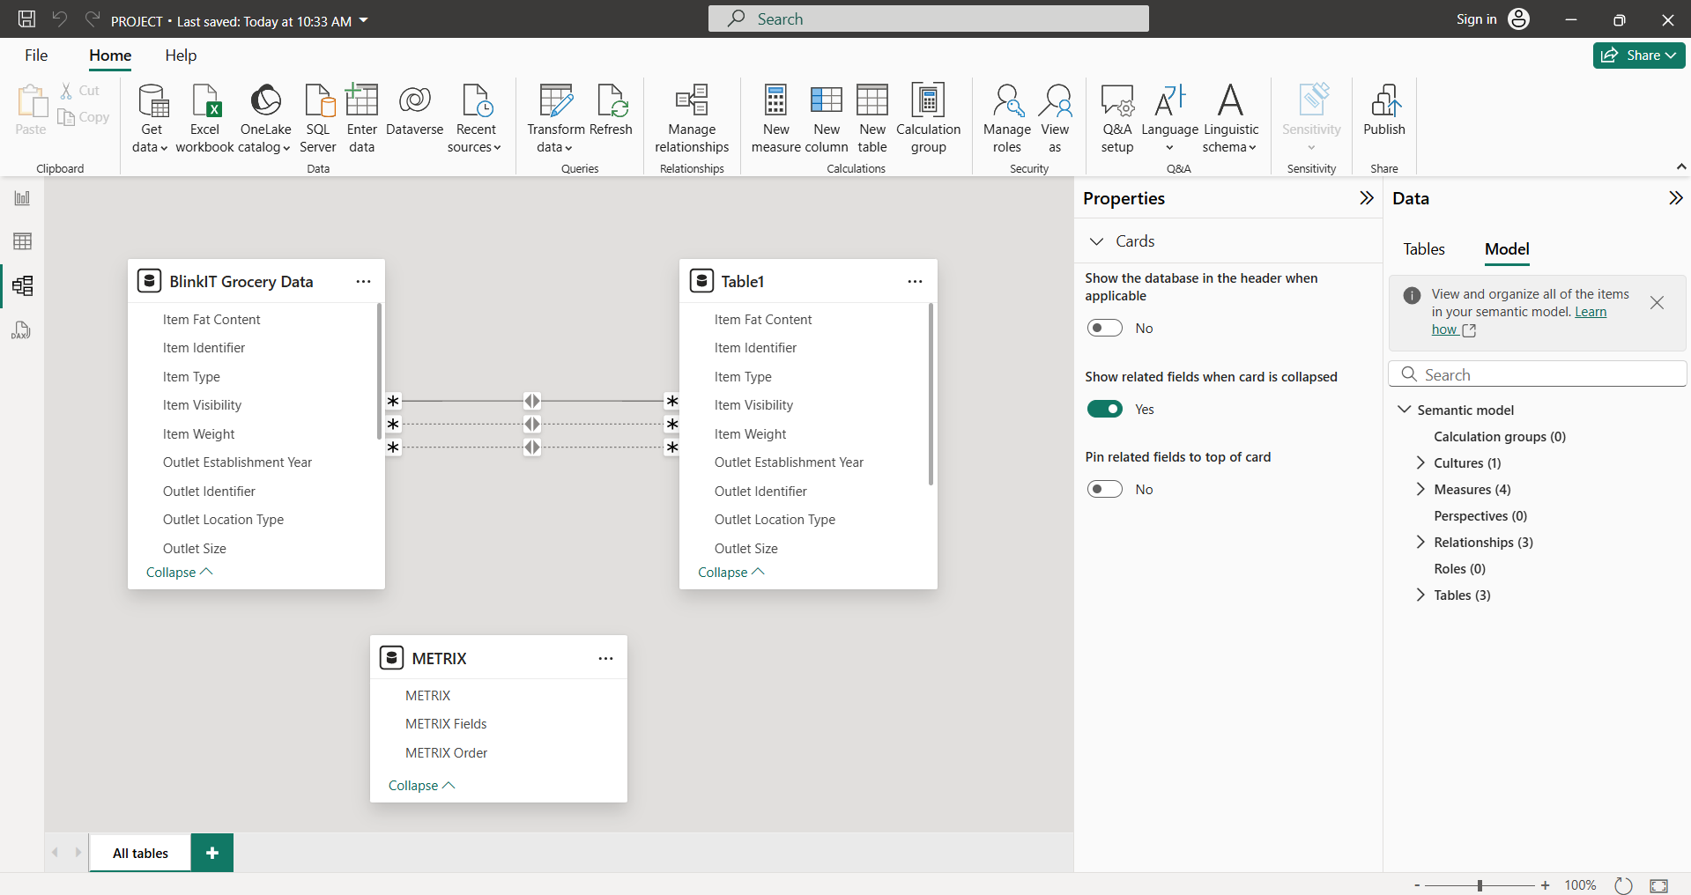
FIGURE 2: Data Model View: Structuring Relationships for Seamless Insights

- Dashboard Design:
Dashboard 1 – “What’s in the Cart?”
🔍 A dashboard specifically designed to examine products stands as the main feature of this system.
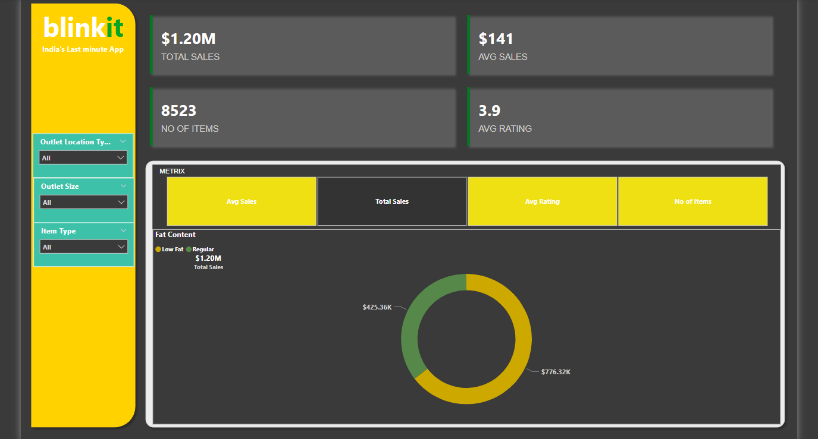
FIGURE 3: Dashboard 1: Focused on Product Performance—fat content, item types, and sales hotspots.
📈 Design Highlights:
- Top-Selling Categories ranked by revenue.
- Item Visibility vs. Sales Correlation.
- The KPI Cards describe Total Sales along with Avg Rating and Avg sales.
🧩 Key Findings:
- After comparing sales statistics regular-fat products outsell low-fat counterparts by 20% thus contradicting the notion that "healthy sells more".
- The revenue statistics place Fruits & Vegetables in the leading position.
- Products that flood the shelves or internet pages achieve better sales because consumers see them easily.

Dashboard 2 – “Store Wars: The Outlet Awakens”
🏪 Outlet-centric dashboard with a zoom into geography and store type
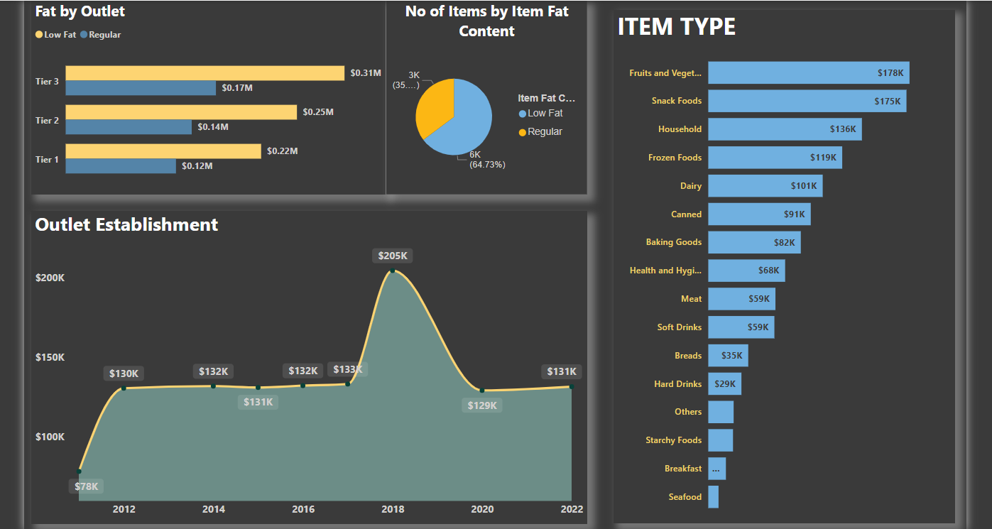
FIGURE 4: Dashboard 2: This dashboard used location tiers in combination with store types and establishment trends for analytics.
📈 Design Highlights:
- Store locations follow a visual layout to show the distribution based on location tiers in the map.
- Sales vs. Establishment Year trendline.
- Pie chart of No of items by Item fat Content.
🧩 Key Findings:
- The grocery sales in Tier 3 locations surpass 45% of the total revenue during customer purchases.
- Newer outlets (post-2015) outperform veterans
- The Supermarket Type1 stores maintain their position as the top-performing grocery outlets within the game.

Dashboard 3 – “The Ingredient Effect”
🥫 Dashboard deep-diving into product characteristics
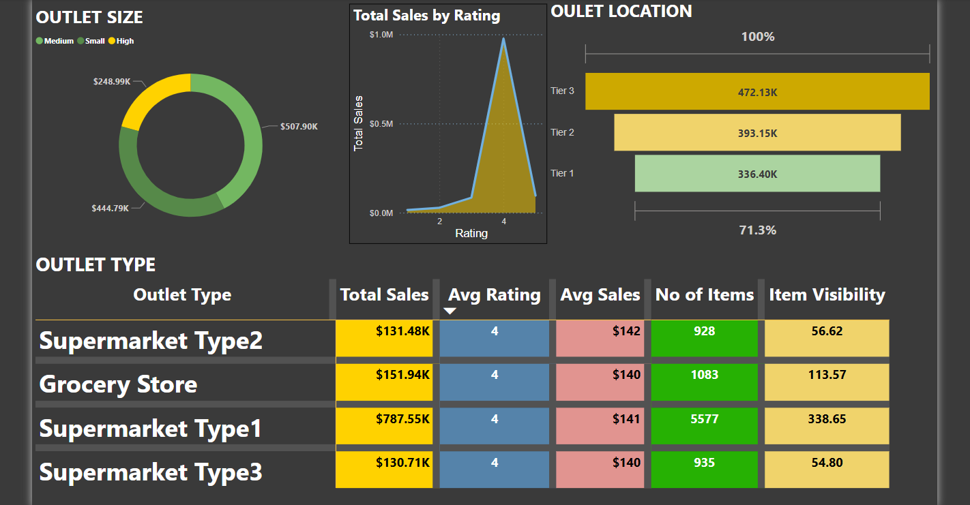
FIGURE 5: Dashboard 3: The third dashboard assessed products through its visibility elements using rating systems and trust signals while maintaining constant weight allocations.
📈 Design Highlights:
- Line graph: Rating vs Total Sales
- KPI Matrix Magic:The bottom-level horizontal matrix uses Total Sales, Average Rating, Average Sales and Number of Items and Item Visibility to analyze four store types making it simple to identify leading and lagging stores immediately.

🧩 Key Findings:
- A manufacturer should choose packaging weights between 13 and 15 kilograms to find the optimal sales range.
- The category of Health & Hygiene items shows a gradual yet constant improvement in sales.
The THREE dashboard reports featured specific sections with colored graphical indicators which used green for growth signals and red for risk warnings together with blue for baseline data. The visual elements included filters for easy understanding together with easy-to-track graphic displays.
- Creative Enhancements:
- Smart tooltips from the system gave users access to supplementary data that appeared when users positioned their cursor above any piece of content. Incorporated conditional formatting to spotlight top/bottom performers. The built-in custom color theme used BlinkIT branding foundations to create genuine visual elements.

Insight Table – The Crystal Ball
💡 Analysis Summary Table
🔮 Dashboard 1: Product Sales Overview – “What’s in the Cart?”
Positive Insights | Negative Insights | Additional Notes
🥦Regular fat foods items gain 20% higher sales than low fat foods– familiarity wins over health. | 🥫 Canned foods perform worst across nearly all outlets. | The product would benefit from either renewing its brand identity or running a package promotion campaign
🥗 Fruits & Vegetables generate the highest combined sales numbers for both volume and monetary value. | ❗ However despite this fact there are low-rated items detected within main category selections. | Quality checks together with supplier changes should be considered for implementation.
🛒 High visibility = high sales. End-of-aisle effect is real! | ⚠️ some products located in barely visible locations continue to stay on shelves. | It is advisable to eliminate these items from the product line or readjust their positions.
🧴 The Health & Hygiene category demonstrates regular weekly consumer interest among household customers. | – | Online “weekly essentials” bundles should include these products for customers..

🏪 Dashboard 2: Outlet Performance – “Store Wars”
Positive Insights | Negative Insights | Additional Notes
🌆 The locations of Tier 3 outlets generate the highest percentage of total revenue at 45%+. | 🚧 At the same time, prime-location Tier 1 outlets show underperformance. | An analysis suggests that the outlets might struggle with local consumer demand or have inadequate marketing efforts.
🏪 Supermarket Type1 stores control every performance measure | 🛑 Type2 stores registered stagnant or declining growth patterns. | The company must evaluate its choice of products and shopping areas for potential changes.
📈 The annual growth rate of stores which started operating since 2015 demonstrates stronger performance compared to outlets established before that year. | ⌛ However, the adoption of new retail patterns is slower when looking at older outlets. | Establish store updating initiatives for outdated locations.
🔝 The bigger the store size the larger become the shopping baskets. More space = more variety. | – | Test cross-merchandising for further upsell.
📦 Dashboard 3: Product Characteristics – “The Ingredient Effect”
Positive Insights | Negative Insights | Additional Notes
🎯 Products that fall within the weight range of 13–15 kg achieve maximum sales volume under golden zone packaging methods. | ❌ Items without weight information perform poorly in the market. | Inventory database cleanup needed.
👀 Speedy product selection occurs when new product SKUs become visible and thus grab customer attention. | ⚠️ Low visibility = low traction, regardless of quality. | Visual arrangement strategies with digital display placements should be used to enhance visibility.
💧 Health & Hygiene items demonstrate a positive monthly trend in their sales | – | Signals a shift toward health-conscious consumer habits.
🔁 The return intervals for repeat items including snacks and beverages persist strongly. | – | The program should encourage customers to subscribe or join loyalty programs based on these items.

Conclusion – The Aisle Ahead
The project involved frozen foods analysis as well as sales flow analysis because it required understanding the factors behind shelf product removal. Power BI transformed static data entries into valuable insights that generated change possibilities.
🏁 What We Learned:
- The actual drivers behind retail product sales success are product fat content characteristics in addition to fixed-size packaging dimensions.
- The third-tier locations represent more opportunities particularly since customers are showing stronger trust.
- Data quality deficiencies especially those leading to unrecorded weights cause immediate and negative consequences to enterprise performance.
🚀 Next Steps for BlinkIT:
- Refine inventory data collection
- Reimagine Tier 1 strategies
- Expand high-performing outlet types
In closing, data isn’t just about numbers—it’s about narratives. And this is grocery galaxy, we just mapped it.

